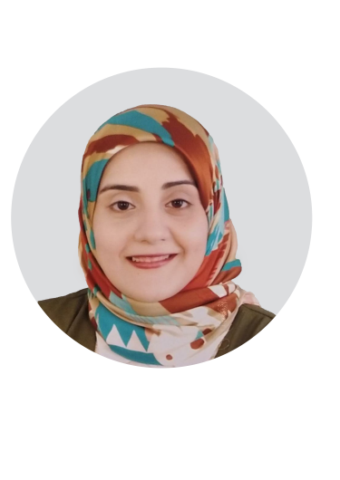

2015

* FACULTY OF MEDICINE

Bachelor of Medicine and Surgery, Assiut University with a (Very Good) grade.

EDUCATION



* Master Of Chest Diseases

Faculty of Medicine, Assuit University, a (very Good) grade.

5 Years

3 Years

* Chest diseases Assistant Lecturer

Faculty Of Medicine, Assuit University

* Chest diseases Resident Lecturer

Faculty Of Medicine, Assuit University

EXPERIENCE

* Interpretation of Pulmonary Function Tests.
* Analysis of Arterial Blood Gases.
* Thoracentesis.
* Ventilator management.
* Bronchoscopy and thoracoscopy.
* Medical History taking
* Critical thinking.
* Time Management.
* Problem Solving

SKILLS

B2

NATIVE

ARABIC

ENGLISH

LANGUAGES

+20 1090078962

azaabahaa270@

gmail.com

Assiut, Egypt

Adress:

Phone:

Email:

HOBBIES

READING

Jul-2020

* How to Write Research Protocol Workshop

Faculty Of Medicine

Jul-2020

* Writing Medical Reports Workshop

Faculty Of Medicine

Jul-2020

* Infection control

Faculty Of Medicine

* Evidence Based Medine

Faculty Of Medicine

Jul-2020

Mar-2017

* Pre-Employment Orientation Program

Faculty Of Medicine

Aug-2016

* Surgical Suturing

Assuit Medical Education Development And Training Center

April-2016

* Infection Control

Assuit Medical Education Development And Training Center

Jun-2016

* Quality Assurance

Assuit Medical Education Development And Training Center

Dec-2012

* Cardio-Pulmonary Resuscitation (C.P.R)

Assuit Medical Education Development And Training Center

2021

ASSISTANT LECTURER, DEPARTMENT OF CHEST DISEASES

BAHAA

AZAA

CONTACT